Experiment n°1:

Flowmeters comparison

# Objective

The purpose of this experiment is to compare three different solutions for the measurement of a flow rate. The fluid used here is water,

The three flowmeter are: a venturi tube, an orifice plate and a rotameter.

Singular head losses of each flowmeter will be determined.

# Description of the installation

The installation used is the HD98B hydraulic bench. Only two pipe will be used: the one with the venturi tube and the one equipped with the orifice plate.

The hydraulic circuit is supplied by water from the tank. The water goes first in the vertical part of the bench, then in the venturi tube or the orifice plate (depending of the pipe used), and finally goes in the rotameter.

The venturi tube is a flowmeter based on the venturi effect, it is basically a convergent pipe linked to a divergent pipe.

The orifice plate is a plate white a hole in the center that allow the fluid to pass it.

The rotameter is a graduated tube similar in shape to a venturi tube, inside the rotameter is a float shaped like whirligig, the ascending flow maintain the float at a certain altitude and give it a rotational movement. The shape of the tube and also the weight, the shape and the dimensions of the float are combined in order to maintain the head losses only a function of the flow rate. The reading is conducted at the top of the float.

# Theories

The flow is supposed permanent, adiabatic and incompressible. Between two point 1 and 2 in a pipe we can apply:

* Flow rate conservation:  
   Qv=S1U1=S2U2
* Bernoulli formula: $P1+\frac{1}{2}ρU1^{2}+ρgz1+ΔPpump=P2+\frac{1}{2}ρU2^{2}+ρgz2+ΔPs+ΔPl$
* Head losses:   
  Head losses are consequences of the actions between the water and pipe, the friction between the water and the pipe result in a loss of pressure. The formula used to calculate head losses is the Darcy-Weisbach formula: $∆Ps=ξ*\frac{L}{D}*\frac{1}{2}*ρ*Um²$

The coefficient ξ depend on the flow of the fluid:

Laminar flow: $ξ=\frac{64}{Re}$ Poiseuille Formula

-Turbulent flow in a smooth pipe: $ξ=\frac{0.316}{\sqrt[4]{Re}}$ (Blasius fromula)

-Turbulent flow in a rough pipe: $\frac{1}{\sqrt{ξ}}=-2log10\left[\frac{ε}{3.71D}+\frac{2.51}{Re\sqrt{ξ}}\right]$ (Colebrook formula)

For singular head losses (minor losses): $∆Ps=K*\frac{L}{D}*\frac{1}{2}ρUm²$ K singular head losses coefficient.

For the orifice plate, the formulas can be used:

⬄) ⬄ introducing the Cd coefficient (because it is not a perfectly laminar flow) and the β=d/D, d diameter of the orifice (m), D diameter of the pipe (m)

$Qv=CSb0\sqrt{\frac{2∆p}{ρ}}$ Introducing C= $Cd\sqrt{\frac{1}{1-β^{4}}}$ Sb0 area of the orifice

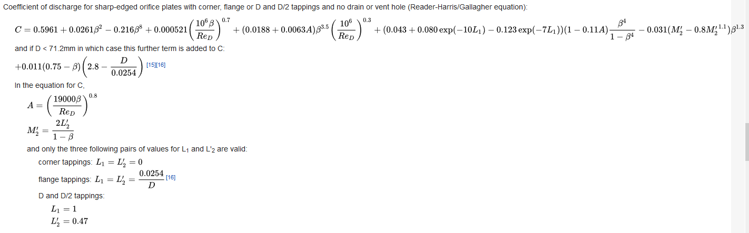Coefficient of discharge can be calculated with the Reader-Harris/Gallagher equation:

# Experiments

a) Purge the pipes liking the bench to the manometers;

b) Check if the exit valve is open;

c) Open the flow control valve;

d) Open the two valve of the desired pipe;

e) Open the rotameter control valve;

f) Connect the manometers to the pipes;

g) Activate the pump;

Pick up the value of Δh and add them in a Δh=f(U) chart.

Conclude on the efficiency of each solutions